Name: Lujain Zia
Roll no: 2023-BSE-034
Date: October 16, 2025

Lab 3
Task 1 – Handling Local and Remote Commit Conflicts (Pull vs Pull --rebase)
- Open your repository on GitHub and edit the README.md file directly in the browser.
- Add a new line such as:
This line was added remotely from GitHub.

Commit your change on GitHub (e.g., message: Remote update to README).
Save a screenshot of your browser showing the change as remote_edit.png.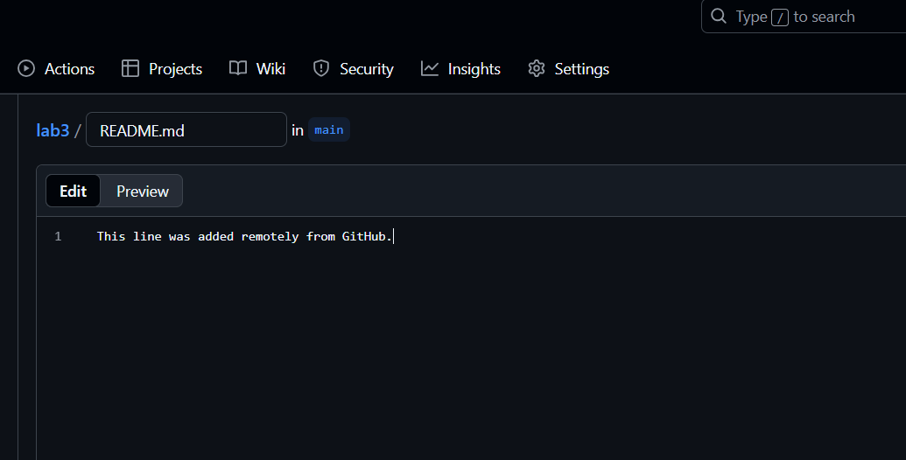

- On your local machine, open the same repository folder.

- Edit the same README.md file locally, for example:
This line was added locally.
- Stage and commit your change:
Save a screenshot of your terminal as local_commit.png.
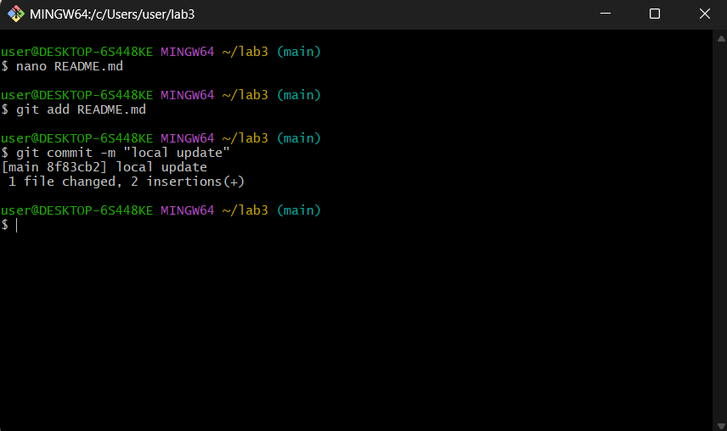

- Try to push:

- git push origin main
You’ll see an error message similar to:
! [rejected] main -> main (fetch first)
error: failed to push some refs to 'github.com:username/repo.git'
hint: Updates were rejected because the remote contains work that you do not have locally.
Save a screenshot of this error as push_error.png.
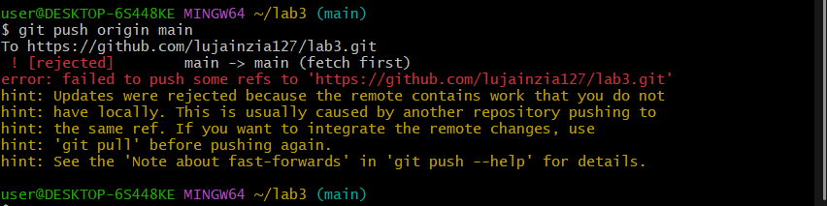

- To fix this, pull the latest changes from remote:
git pull --no-rebase origin main
Git will merge your local and remote commits, creating a merge commit.
Save a screenshot as merge_commit.png.
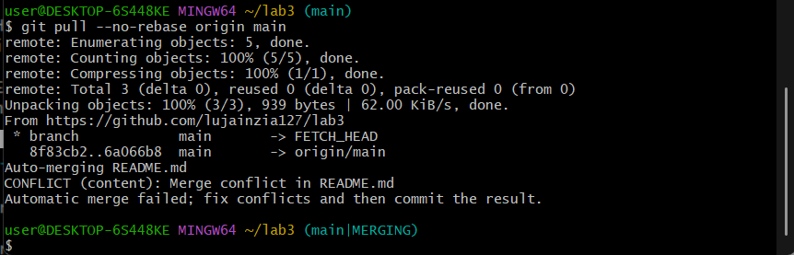
- Push again:
Save a screenshot as push_after_merge.png.
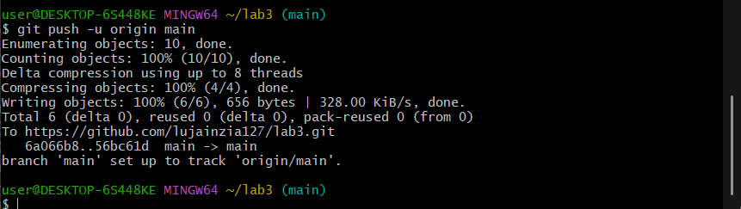

- Now repeat the same process, but this time use rebase instead of merge:

- Make another remote edit on GitHub in README.md.
- Then make another local edit and commit it.
- Instead of using git pull, run:
Save a screenshot as rebase_pull.png.
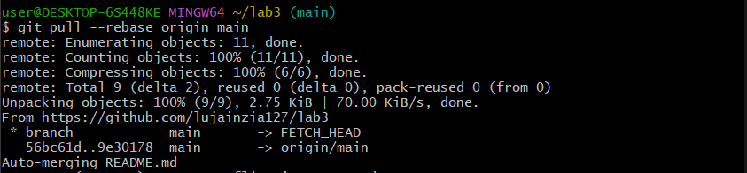
- Push again:
Save a screenshot as push_after_rebase.png.
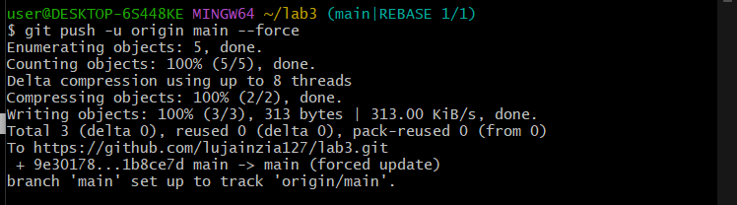

Task 2 – Creating and Resolving Merge Conflicts Manually
- On GitHub (remote), open your README.md file and change an existing line.
For example, if it currently says:
This line was added remotely from GitHub.
Change it to:
This line was updated remotely again.

Commit your change with the message: Remote conflicting change
Save a screenshot as remote_conflict_edit.png.
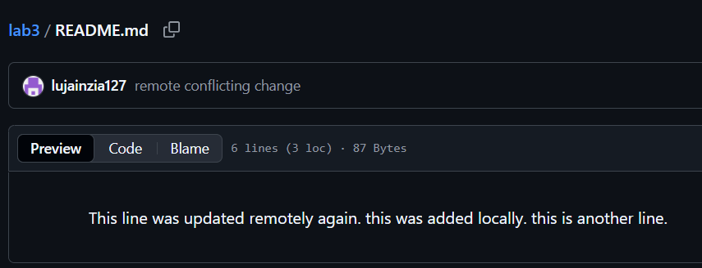
- On your local machine, edit the same line in the same file but make a different change:
This line was updated locally at the same time.
Save a screenshot of your edit in VS Code as local_conflict_edit.png.
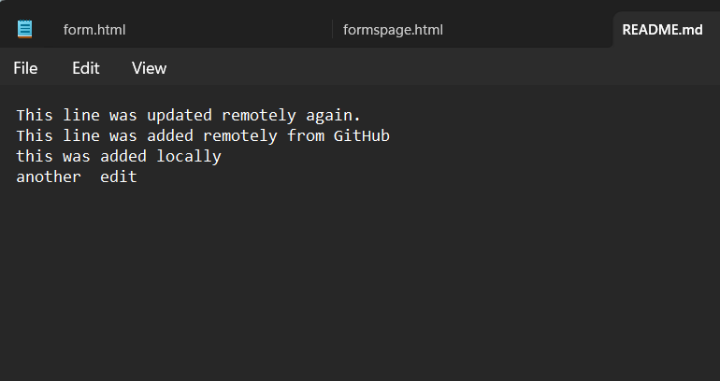
- Stage and commit your local change:

git add README.md
git commit -m "Local conflicting change"
Save a screenshot as local_conflict_commit.png.
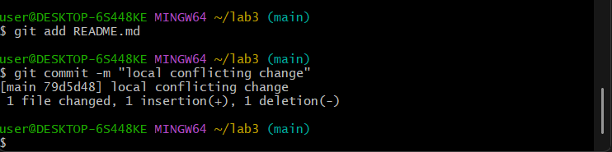
- Try to push:
The push will be rejected, since the remote version has conflicting changes.
Save a screenshot of this error as conflict_push_error.png.
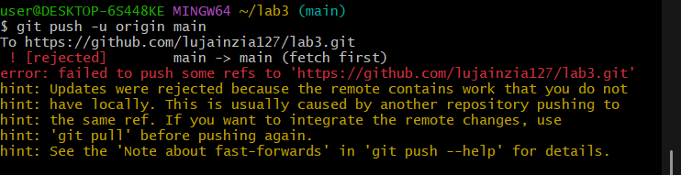
- Pull with rebase to bring in remote changes:
git pull --rebase origin main
Git will pause the rebase and notify you about a conflict.
Save a screenshot of the conflict message as conflict_message.png.
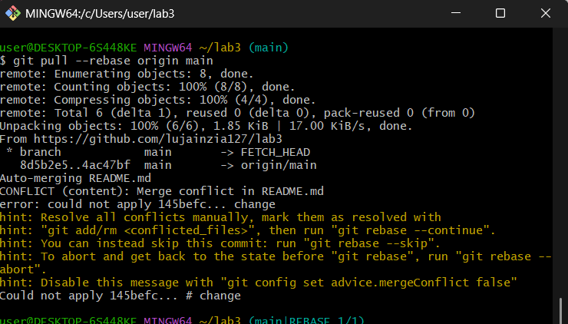
- Open the README.md file in your editor — you’ll see conflict markers like this:

<<<<<<< HEAD
This line was updated locally at the same time.
=======
This line was updated remotely again.
>>>>>>> origin/main
Manually edit the file to keep the correct line (for example, merge both ideas).
Save a screenshot of the resolved file as resolved_readme.png.
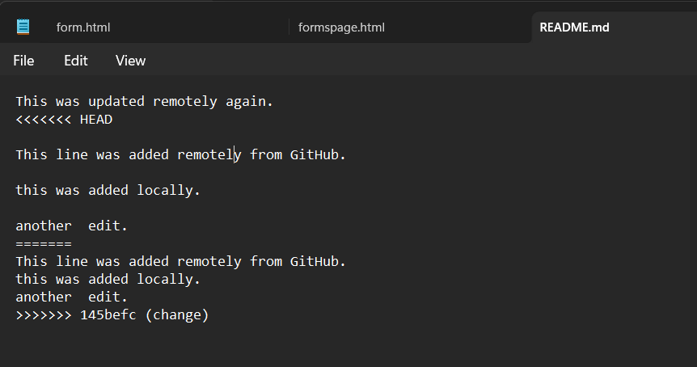
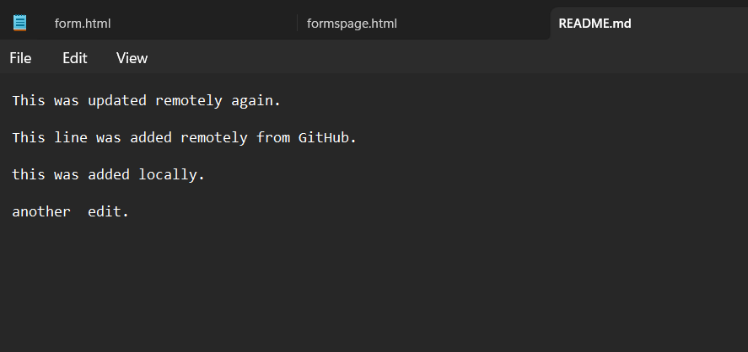
- After fixing the file, mark the conflict as resolved and continue the rebase:

git add README.md
git rebase --continue
Save a screenshot of this step as rebase_continue.png.
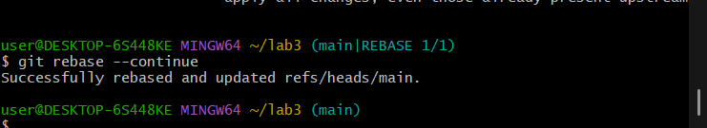
- Finally, push your changes:
git push -u origin main
Save a screenshot as push_after_resolve.png.
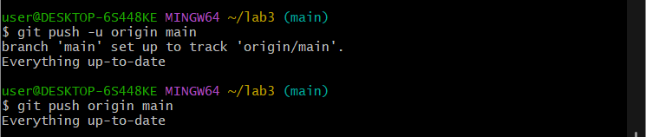

Task 3 – Managing Ignored Files with .gitignore and Removing Tracked Files
Steps
- Create a new folder named textfiles inside your repository:
mkdir textfiles
- Inside the textfiles folder, create three text files:
echo "File A content" > textfiles/a.txt
echo "File B content" > textfiles/b.txt
echo "File C content" > textfiles/c.txt
- Add and commit the new directory:
git add .
git commit -m "Added textfiles directory with three files"
git push origin main
Save a screenshot as push_textfiles.png.
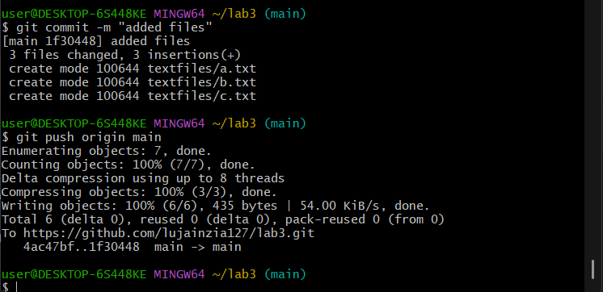
- Now, create a .gitignore file in the root of your repository:
echo "textfiles/*" > .gitignore
- Add and commit the .gitignore file:
git add .gitignore
git commit -m "Added .gitignore to ignore textfiles directory"
git push origin main
Save a screenshot as gitignore_push.png.
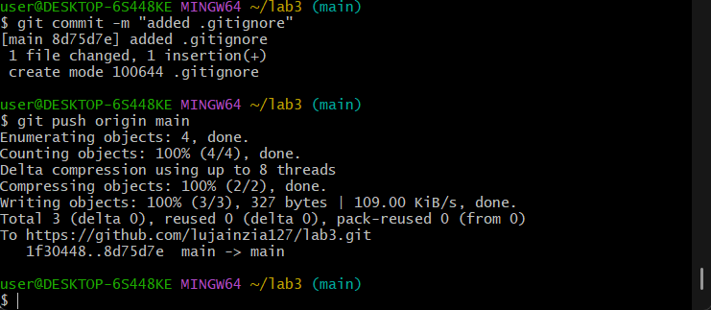
- Go to GitHub and check your repository — notice that the textfiles directory is still visible on the remote.
Save a screenshot as repo_still_has_textfiles.png.
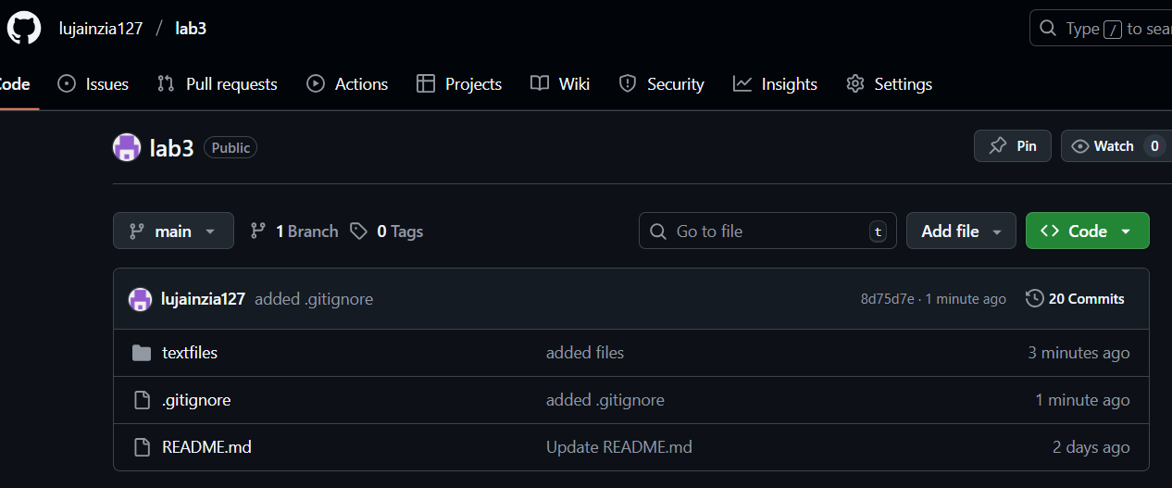
- To remove already tracked files from Git (but not from your local system), run:
git rm -r --cached textfiles
- Commit and push again:
git add .
git commit -m "Removed tracked textfiles directory"
git push origin main
Save a screenshot as rm_cached_push.png.
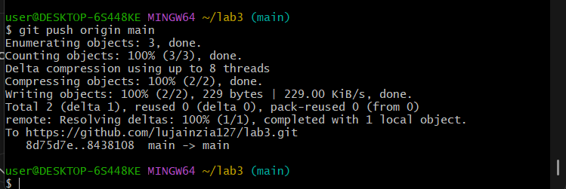
- Check your GitHub repository again — the textfiles folder should now be deleted remotely.
Save a screenshot as repo_textfiles_removed.png.
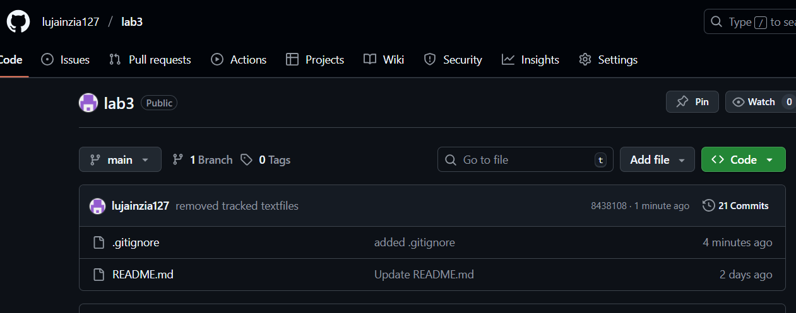

Task 4 – Create Temporary Changes and Use git stash
- Create a feature-branch.
git checkout -b feature-branch

- Modify any file (for example, README.md) by adding a few test lines.

git add README.md
git commit -m "Changes the README.md file"
Save a screenshot as modified_readme.png.
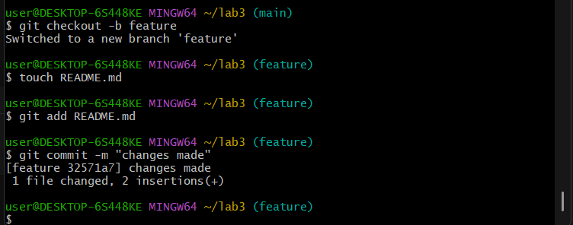
- Modify any file (for example, README.md) by adding a few new lines.
- Without committing or stashing the changes, try to switch to another branch:
git checkout main
You’ll see an error message similar to:

error: Your local changes to the following files would be overwritten by checkout:
README.md
Please commit your changes or stash them before you switch branches.
Save a screenshot as checkout_error.png.
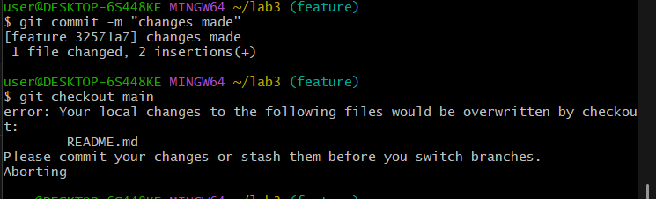
- To fix this, stash your changes:
git stash
Save a screenshot as stash_command.png.
- Try switching branches again — it should now work:
git checkout main

Save a screenshot as branch_switched.png.
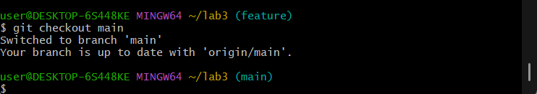
- Return to your previous branch (for example, feature-branch):

git checkout feature-branch
Save a screenshot as back_to_feature.png.
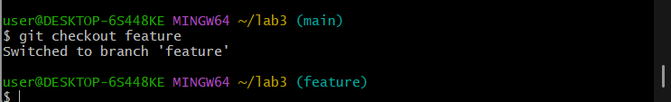
- Check your working directory status:

git status
It should show:
nothing to commit, working tree clean
Save a screenshot as status_clean.png.
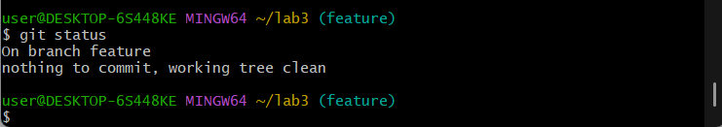
- Now restore your stashed changes:

git stash pop
You’ll see a message indicating that changes were reapplied:

On branch feature-branch
Changes not staged for commit:
(use "git add <file>..." to update what will be committed)
(use "git restore <file>..." to discard changes in working directory)
Save a screenshot as stash_pop.png.
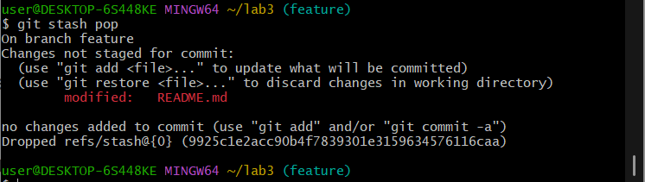
- Confirm that your previous edits are back in the file.
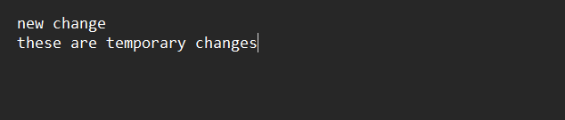

Task 5 – Checkout a Specific Commit Using git log
- View commit history:
git log --oneline
Save a screenshot as log_before_checkout.png.
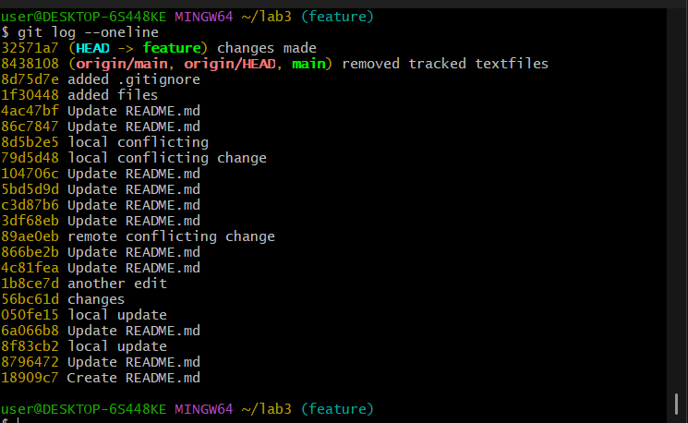
- Copy any previous commit hash (e.g., a1b2c3d).
- Checkout that commit:

git checkout <commit-hash>
Save a screenshot as detached_head.png.
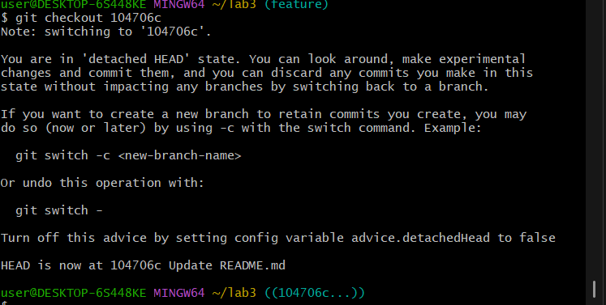
- To return to your main branch:

git checkout main
Save a screenshot as back_to_main.png.
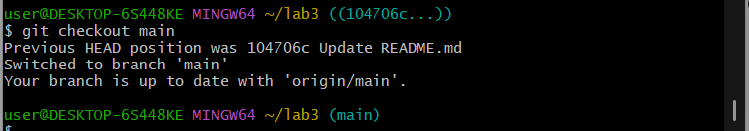

Task 6 – Resetting Commits (Soft vs Hard Reset) (With Verification Steps)Steps

- Add a new line in any file and commit it:

# Edit any file (e.g., README.md), add a line
git add .
git commit -m "Added test line"
Save a screenshot as first_commit.png.
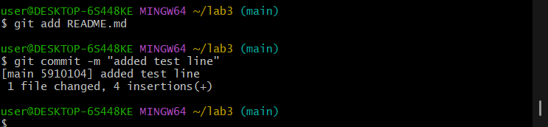
- Add another change and commit again:

# Edit the file again, add a different line
git add .
git commit -m "Second test commit"
Save a screenshot as second_commit.png.
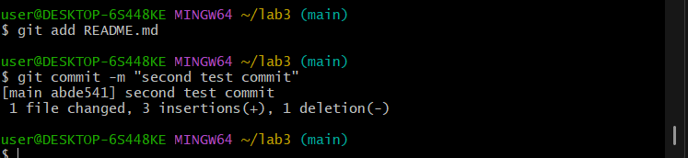
- View the history before reset:
git log --oneline
Save a screenshot as log_before_reset.png.
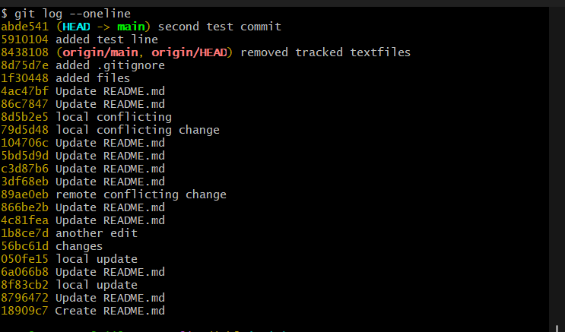
- Check file contents for both changes:
Open the edited file (e.g., README.md) and visually confirm BOTH added lines exist.
Save a screenshot as file_before_reset.png.
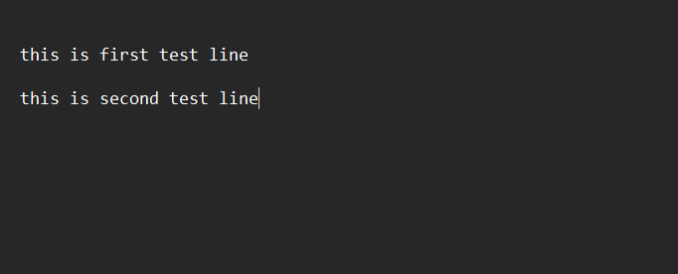
- Perform a soft reset (keeps changes in working directory):

git reset --soft HEAD~1
Save a screenshot as soft_reset.png.
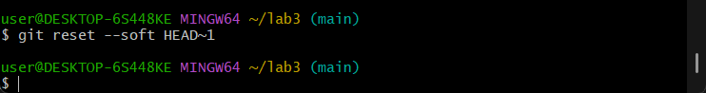
- Check commit history after soft reset:
git log --oneline
Save a screenshot as log_after_soft_reset.png.
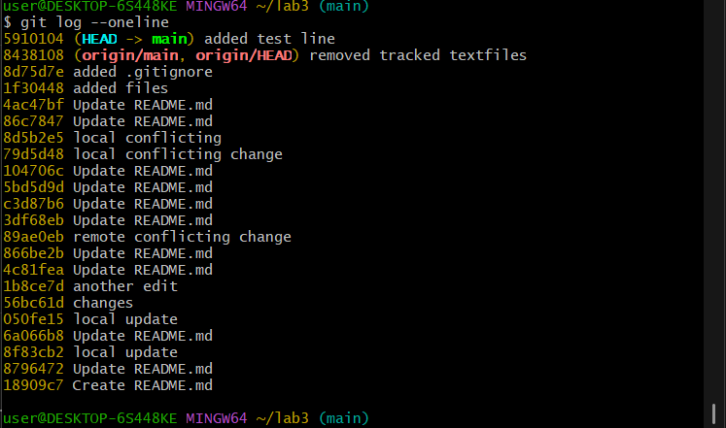
- Verify changes in the file:
Open the file again and confirm both edits are still present (nothing lost).
Save a screenshot as file_after_soft_reset.png.
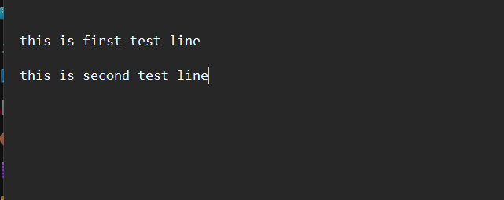
- Check git status:
git status
You should see your changes are staged (ready to commit again).
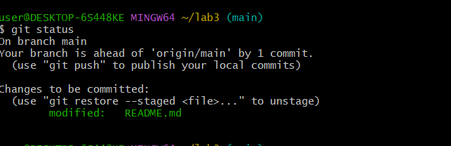
- Perform commit
git commit -m "Second Test commit"
Save a screenshot as file_after_hard_reset.png.
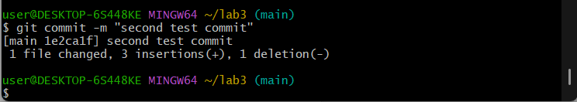
- Perform a hard reset (discards changes completely):
git reset --hard HEAD~1
Save a screenshot as hard_reset.png.
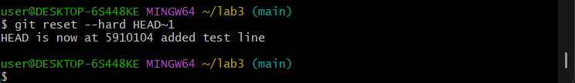
- Check commit history after hard reset:
git log --oneline
Save a screenshot as log_after_hard_reset.png.
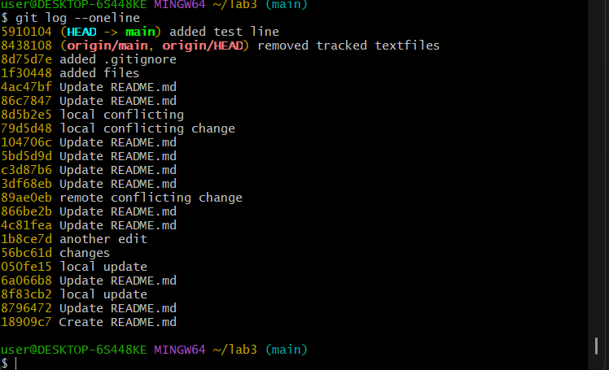
- Verify changes in the file:
Open the file and confirm the second edit is gone (reverted to previous commit).
Save a screenshot as file_after_hard_reset.png.
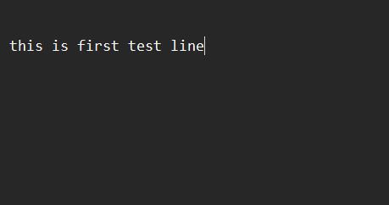
- Check git status:
git status
Should report "nothing to commit, working tree clean".
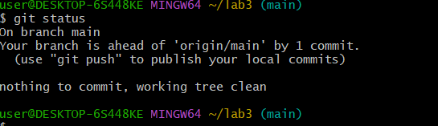

Task 7 – Amending the Last Commit
- Make a small change in any file.
- Stage it and commit:
git add .
git commit -m "Fix log message"
Save a screenshot as first_amend_commit.png.
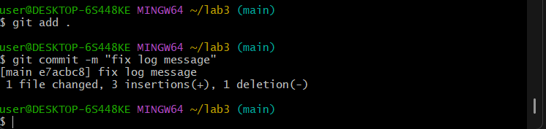
- Realize you forgot to change another file. Update it now.
- Add it and amend the last commit:
git add .
git commit --amend
Save a screenshot as amend_commit.png.
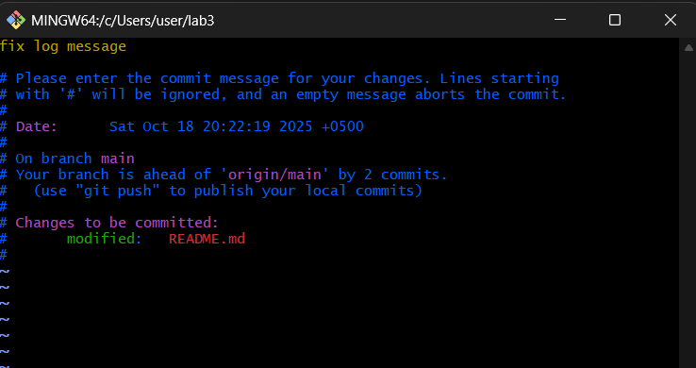
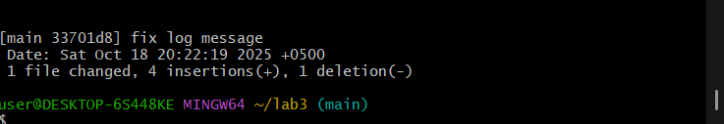

Task 8 – Reverting a Commit (Safe Undo on Remote Branch)
- Make a change and commit it:
echo "temporary text" >> temp.txt
git add .
git commit -m "Added temporary text file"
git push origin main
Save a screenshot as commit_temp_file.png.
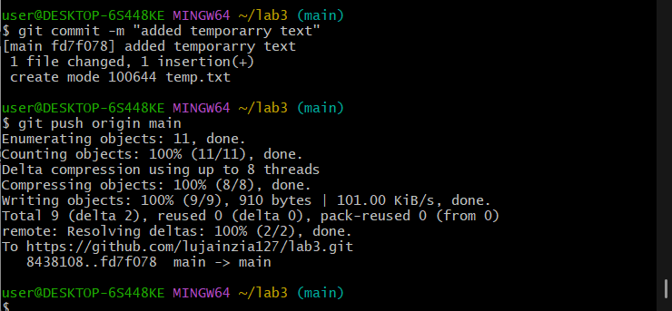
- Now revert that commit safely (do not delete it):

git log --oneline
git revert <commit-hash>
Save a screenshot as revert_commit.png.
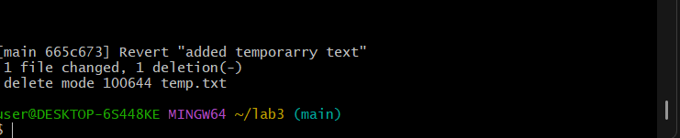
- Push the revert commit:

git push origin main
Save a screenshot as revert_push.png.
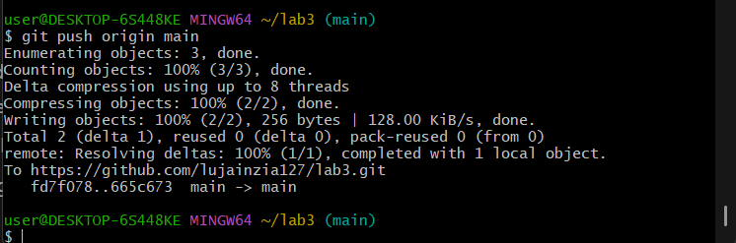

Task 9 – Force Push (With Caution)
Use this only in your own branch (never on main or develop).

- Create a new branch:

git checkout -b test-force
Save a screenshot as new_branch.png.
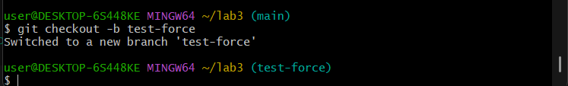
- Make and commit a small change.
Save a screenshot as force_commit.png.
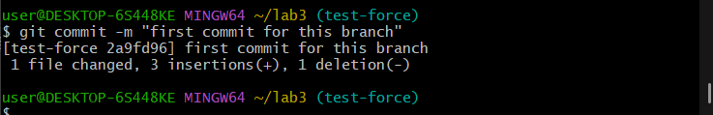
- Push it:

git push origin test-force
Save a screenshot as push_force_branch.png.
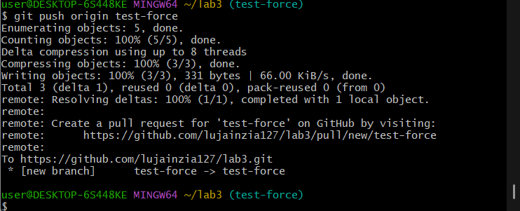
- Perform a hard reset:

git reset --hard HEAD~1
Save a screenshot as hard_reset_force.png.
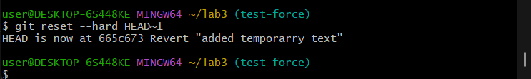
- Push again

git push origin test-force
Rejected by remote repository
Save a screenshot as normal_push.png.
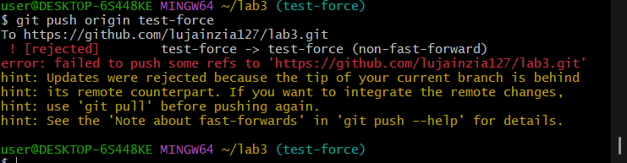
- Now force-push to remote:
git push origin test-force --force
Save a screenshot as force_push.png.
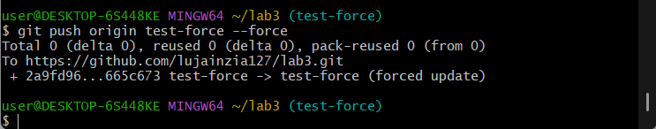

Task 10 – Running Gitea in GitHub Codespaces via Docker Compose
Steps
- Fork the Gitea Repository

Go to Gitea.
Click the Fork button at the top right and fork it into your own GitHub account.
Save a screenshot of your forked repository page as forked_gitea.png.
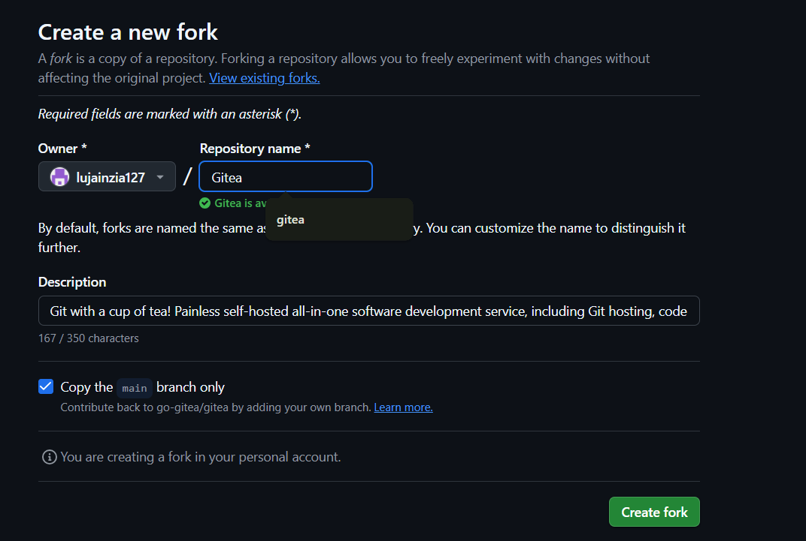
- Open the Forked Repo in GitHub Codespaces
On your forked repo, click Code > Codespaces > Create codespace on main.
Save a screenshot of the Codespace loading as codespace_loading.png.
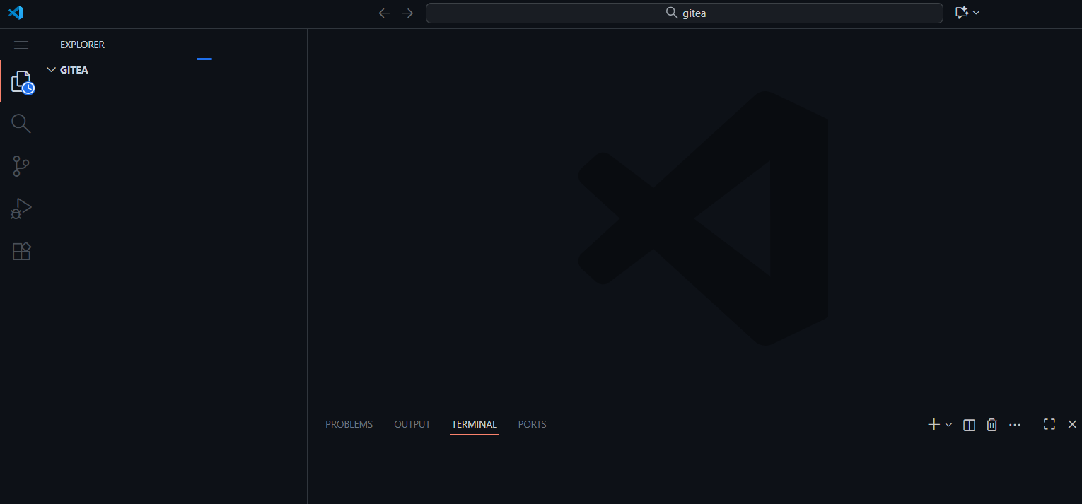
- Start Gitea with Docker Compose
In the Codespace terminal, run:
docker compose up -d
Wait for the containers to start.
Save a screenshot of the terminal showing the containers running as docker_up.png.
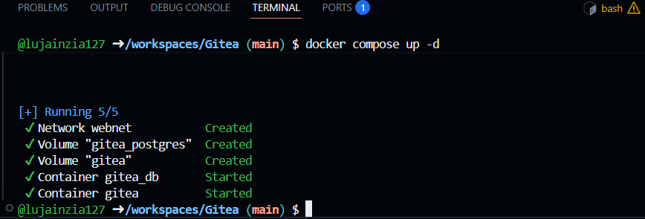
- Access Gitea Web Interface
In Codespaces, forward port 3000 (see Codespaces port forwarding UI).
Change the Visibility of port 3000 from private to public.
Click the forwarded port 3000 link to open Gitea in your browser tab.
Save a screenshot of the Gitea install page as gitea_install_page.png.
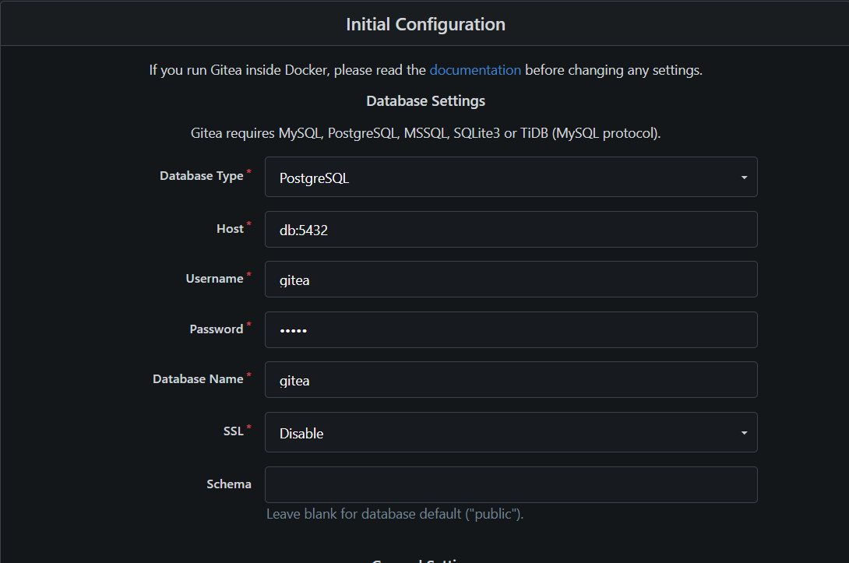
- Install Gitea
Fill out the installation form, providing an admin username and password (e.g., admin / yourpassword).
Save a screenshot of the completed setup (show the admin account setup) as admin_setup.png.
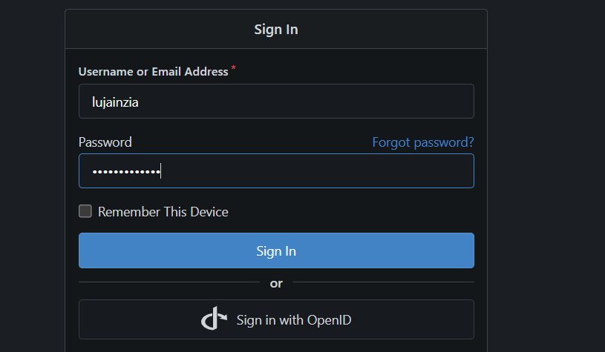
- Log In to Gitea
Use your admin credentials to log in.
Save a screenshot of the Gitea dashboard after login as gitea_dashboard.png.
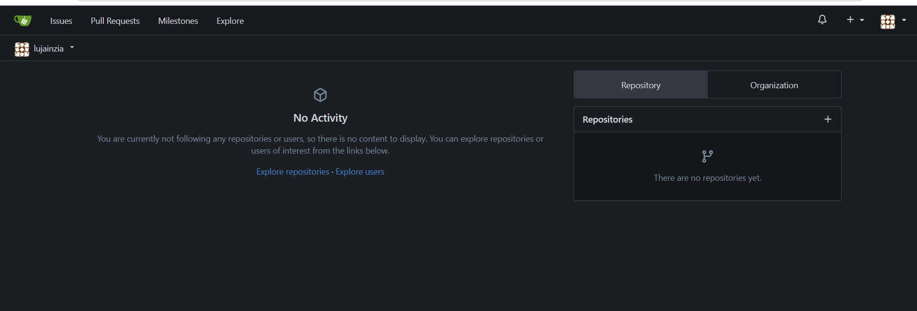
- Create a New Repository in Gitea
Click New Repository or + > New Repository in Gitea.
Fill out the repository details and create it.
Save a screenshot of the new repository page as gitea_new_repo.png.
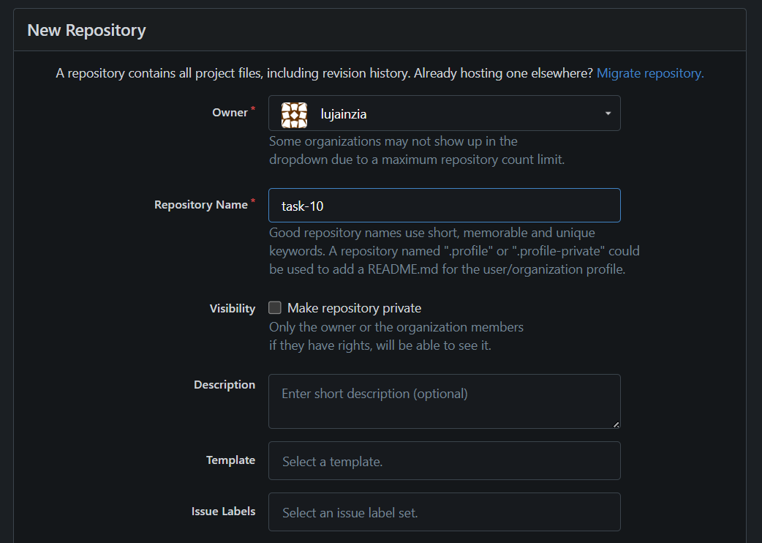
Task 11 – Creating a GitHub Pages Portfolio Site
- Create a GitHub Pages Repository
Go to GitHub and create a new repository named <your-username>.github.io
(e.g., if your username is WaqasSaleem97, the repo should be WaqasSaleem97.github.io).
Make sure the repository is public.
Save a screenshot of the newly created repository as github_pages_repo.png.
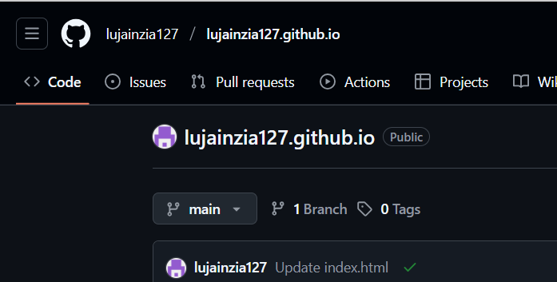2. Add Static Website Code

Prepare a simple static website (e.g., your CV or portfolio) in HTML/CSS/JS by using the sample code provided in the repository Iqra Bashir CV.
Put your files in a local folder.
Save a screenshot of your local files as local_static_site.png.
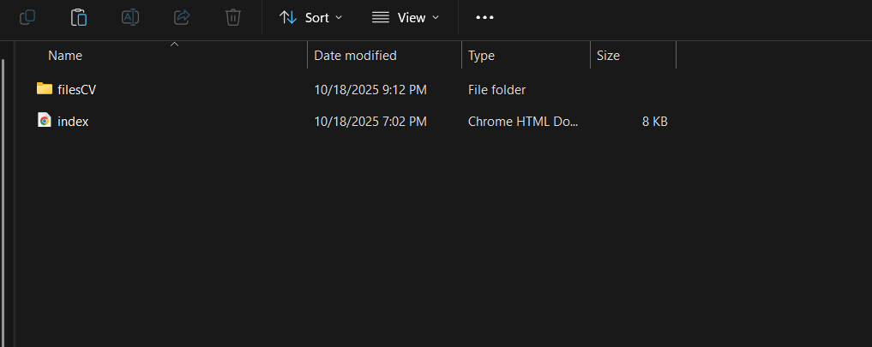
- Push the Files to GitHub

Initialize git in your folder (if not already):
git init
git remote add origin git@github.com:<your-username>/<your-username>.github.io.git
Add and commit your files:
git add .
git commit -m "Add portfolio site for GitHub Pages"
git push -u origin main
Save a screenshot of your terminal showing a successful push as push_static_site.png.
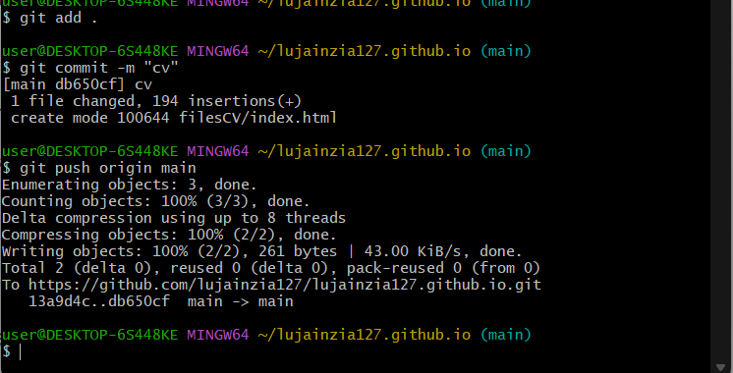
- Check GitHub Pages Settings
Go to your repository on GitHub.
Click Settings > Pages.
Confirm that your site is published and see the link to your live site (e.g., https://your-username.github.io).
Save a screenshot of the Pages settings as github_pages_settings.png.
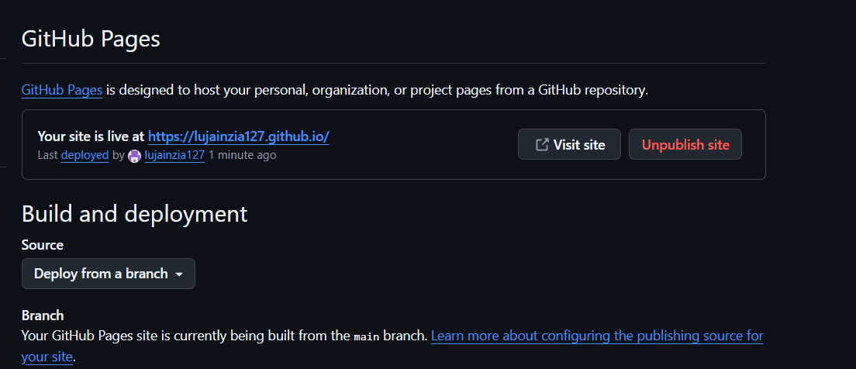
- Visit Your Live Site
Open your GitHub Pages site in the browser.
Save a screenshot of your live site as live_site.png.
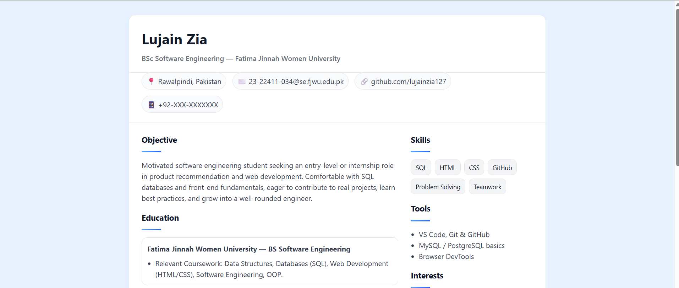

Exam Evaluation Questions
1. Local vs Remote Conflict Resolution
Steps:

On GitHub, edit a file (e.g., README.md) and commit the change.
Screenshot as Q1_remote_edit.png
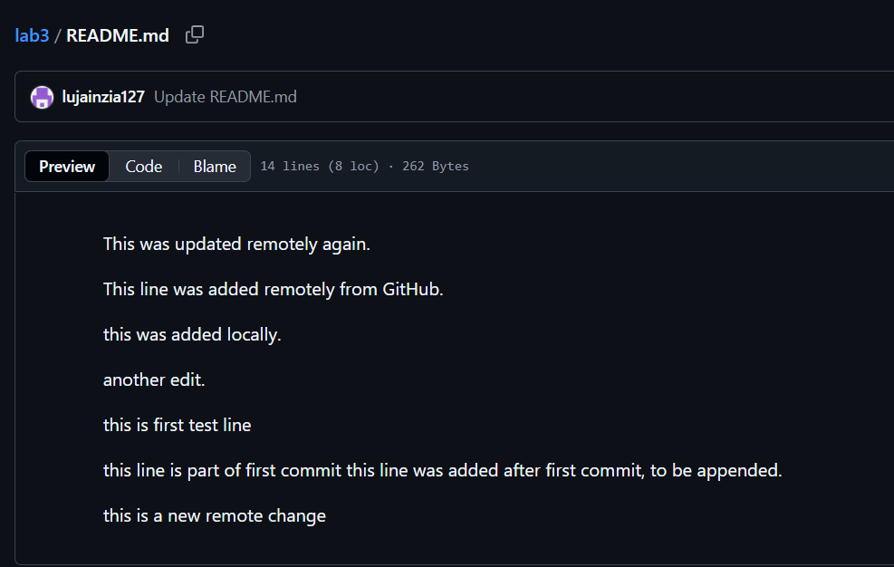
On your local machine, edit the same file differently (Avoid Conflict) and commit.
Screenshot as Q1_local_edit.png
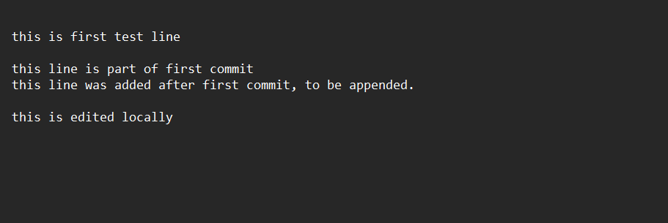
Try to push your local commit and observe the error.
Screenshot as Q1_push_error.png
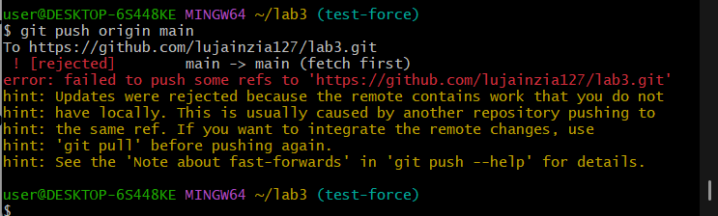
Resolve the conflict by running git pull (merge), then push.
Screenshot as Q1_merge_resolution.png
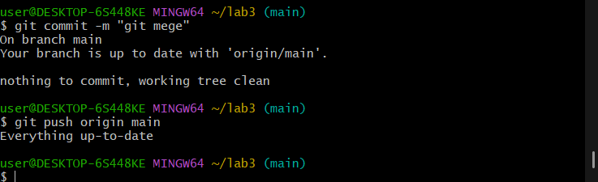

Repeat with another remote/local change, but resolve using git pull --rebase, then push.
Screenshot as Q1_rebase_resolution.png
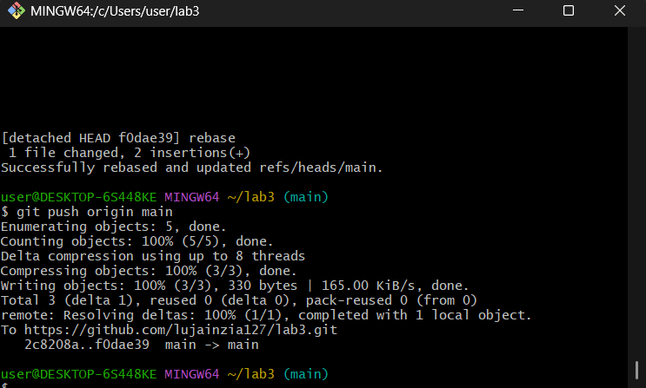
2. Manual Merge Conflict Handling
Steps:
On GitHub, change a specific line in a file and commit.
Screenshot as Q2_remote_conflict_edit.png
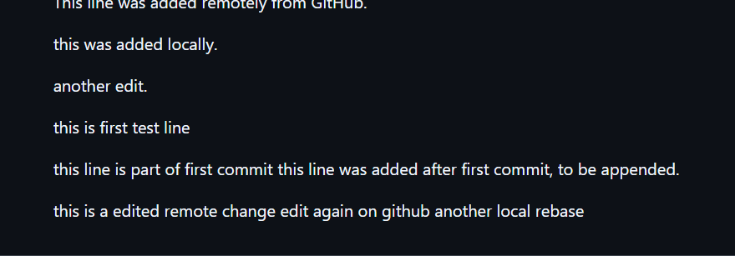
Locally, change the same line differently and commit.
Screenshot as Q2_local_conflict_edit.png
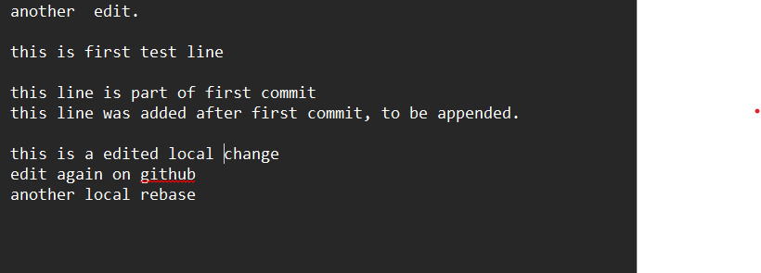

Try to push your local change and observe the conflict error.
Screenshot as Q2_conflict_push_error.png
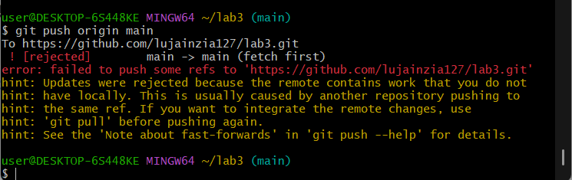
Use git pull --rebase to fetch changes and trigger the conflict.
Screenshot as Q2_rebase_conflict.png
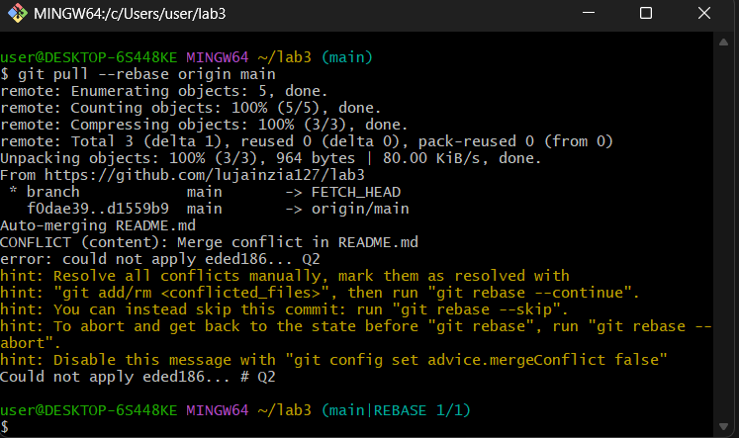
Edit the conflicted file to resolve the conflict manually.
Screenshot as Q2_resolved_file.png
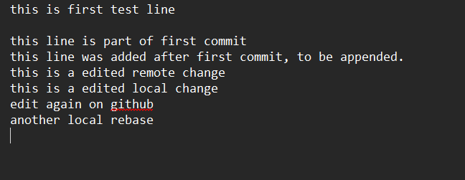

Mark the conflict resolved (git add <file>, git rebase --continue) and push.
Screenshot as Q2_resolution_complete.png

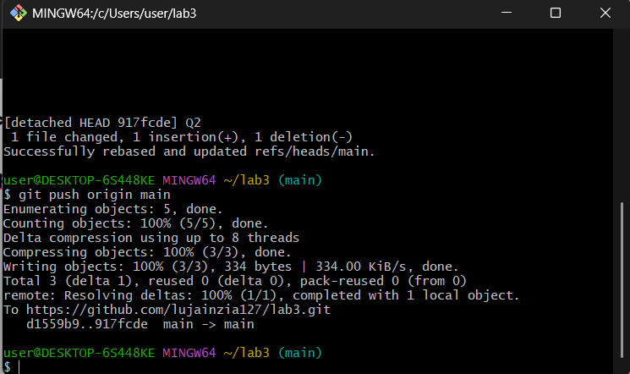

3. Managing Ignored and Tracked Files
Steps:
Create a new folder (e.g., DocFiles) and add several files inside.
Screenshot as Q3_folder_created.png
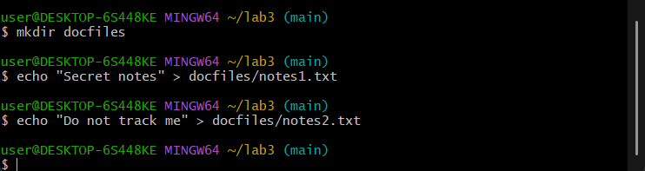
Commit and push the folder/files to GitHub.
Screenshot as Q3_files_pushed.png
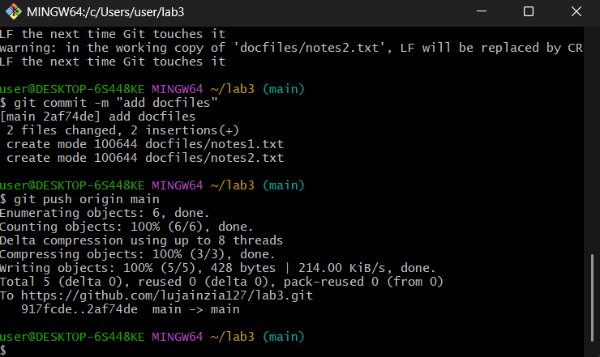
Add the folder to your .gitignore file.
Screenshot as Q3_gitignore_added.png
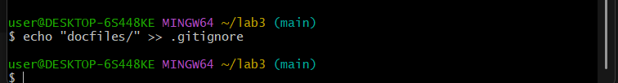
Commit and push the .gitignore update
Screenshot as Q3_gitignore_pushed.png
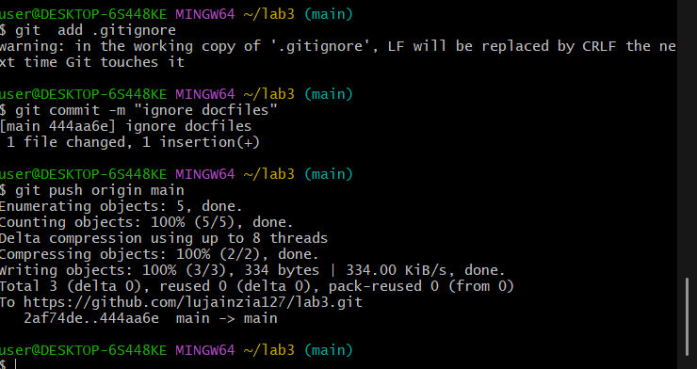
Remove the folder from tracking using git rm -r --cached <folder>.
Screenshot as Q3_folder_untracked.png
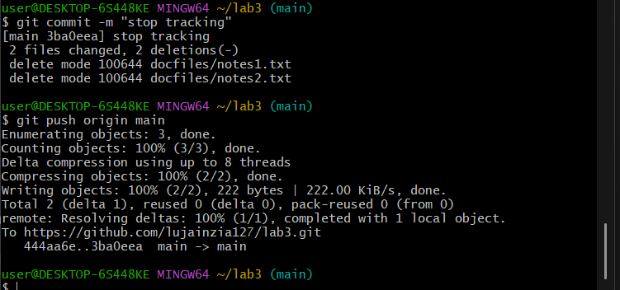
Commit and push the change, then verify the folder is no longer tracked on GitHub.
Screenshot as Q3_folder_removed_github.png
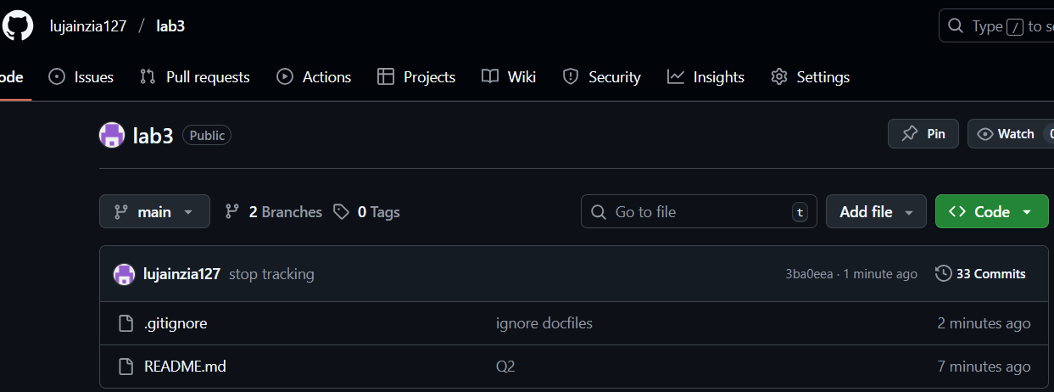
4. Commit History Manipulation and Recovery
Steps:
Make a change and commit it.
Screenshot as Q4_first_commit.png
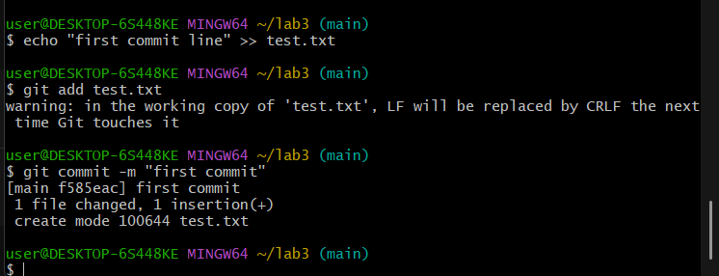
Make another change and commit again.
Screenshot as Q4_second_commit.png
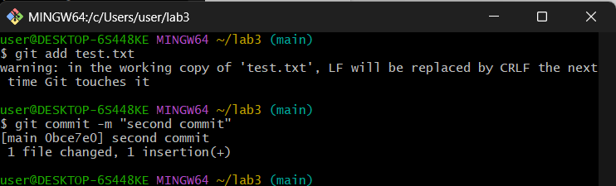View your commit history.
Screenshot as Q4_commit_history.png
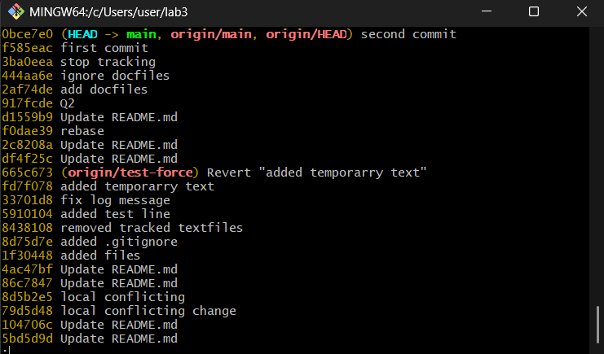
Perform a soft reset (git reset --soft HEAD~1) and observe your file and history.
Screenshot as Q4_soft_reset.png
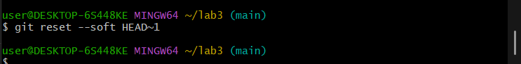
Make commit again.
Screenshot as Q4_third_commit.png
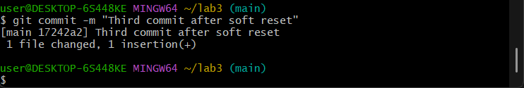
Perform a hard reset (git reset --hard HEAD~1) and observe the changes.
Screenshot as Q4_hard_reset.png

